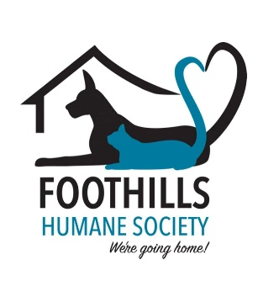
PET ADOPTION APPLICATION

Name: _____________________________________________________________
Physical Address: ____________________________________________________
City: _____________________ State: ____________ Zip: ____________________
Primary Phone: ___________________ Alternate Phone: ____________________
Email Address: ______________________________________________________

Name of animal you wish to adopt: _____________________________________
Are you at least 18 years old? ________Yes ___________No
Describe your ideal pet: _______________________________________________
Do you live in a house or apartment? ____________________________________
Do you rent? _________ own? ________ still living at home? ________________
If you rent, are you aware of your pet policy? _____________________________
Does every member of your household know about and agree with you intentions to adopt? ________Yes _______ No
Will there be children under 10 years of age in the home? ______Yes _______No
Do you have any other pets in the home? _______ If yes, what kind and how many? ___________________________________________________________________
___________________________________________________________________
Are your pets spayed/neutered? _______Yes ________No
Who is your veterinarian? _____________________________________________
How much do you know about heartworm disease? ___________________________________
If interested in a cat/kitten, do you plan to declaw? ___________________________________
If interested in a dog, do you have a fenced yard? _____________________________________
Where will your adopted pet spend most of its time? Where will the pet be when you are not home? Please explain in as much detail as possible. ___________________________________
_____________________________________________________________________________
Describe what your pets activity level will look like: ___________________________________
_____________________________________________________________________________
Have you ever given up a pet in the past? ________ Yes _______ No
If yes, please explain the circumstances:____________________________________________
_____________________________________________________________________________
_____________________________________________________________________________
How did you hear about us? ______________________________________________________

